**CHAPTER 4**

In Windows programming, the client area is the part of the application window that is not taken up by the title bar, window-sizing border, and other elements.

Windows programs must be able to handle client areas of varying sizes, from very small to very large.

The process of displaying text or graphics in a Windows program's client area is called "painting."

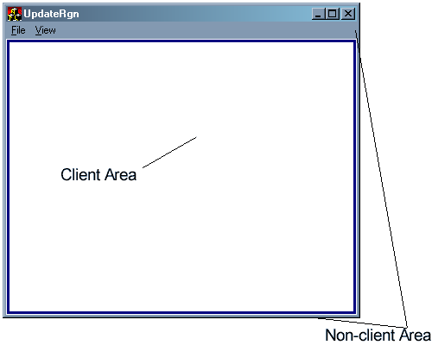

Windows provides a **Graphics Device Interface (GDI)** for painting, but in this chapter we will focus on displaying simple lines of text.

Windows programs should use the system font as the default font, as this ensures consistent appearance across different systems.

Device-independent programming is the practice of writing software that can run on a variety of hardware and software configurations.

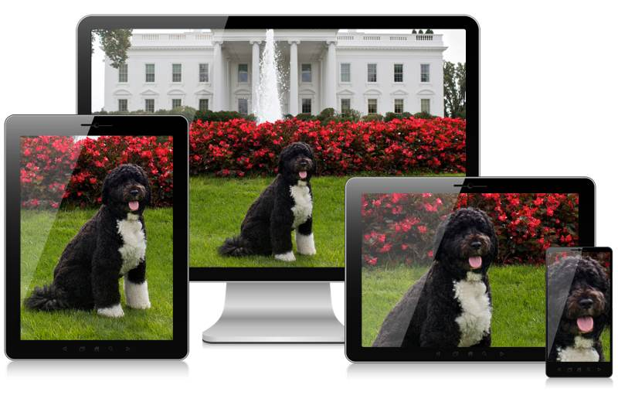

Windows programs can obtain information about their environment using Windows facilities.

The size of the client area can change at any time, so Windows programs need to be able to react to these changes.

Windows programs can use a variety of techniques to make their output look good on different screen sizes.



Device-independent programming is an important skill for any Windows programmer.

In Windows, programs can only draw text and graphics in the client area of their window.

Windows may inform a window procedure that part of the window's client area needs painting by posting a WM_PAINT message.

A window procedure can receive a WM_PAINT message for a variety of reasons, such as when a hidden area of the window is brought into view or when the user resizes the window or a tooltip is displayed.

In some cases, Windows may post a WM_PAINT message when it is not strictly necessary to repaint the client area.

Windows always saves the area of the display it overwrites and then restores it in a few cases, such as when the mouse cursor is moved across the client area or when an icon is dragged across the client area.

Windows programs should be prepared to receive WM_PAINT messages at any time.

Windows programs should be able to repaint their entire client area if necessary.

Windows programs can use the InvalidateRect or InvalidateRgn function to explicitly generate a WM_PAINT message.

Here is an example of how to handle a WM_PAINT message in a Windows program:

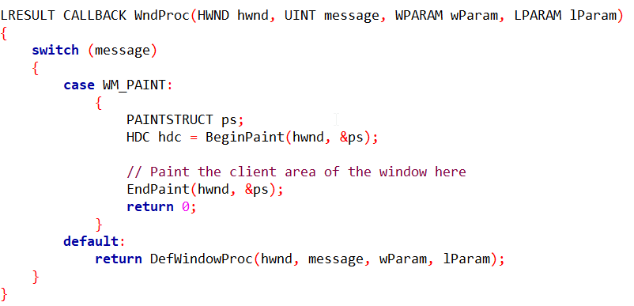

This code is the window procedure for a Windows program. The window procedure is responsible for handling all messages sent to the window, including WM_PAINT messages.

LRESULT CALLBACK WndProc(HWND hwnd, UINT message, WPARAM wParam, LPARAM lParam): This line defines the window procedure function. The function takes four parameters:

* hwnd: The handle of the window
* message: The message that was sent to the window
* wParam: Additional message-specific information
* lParam: Additional message-specific information

switch (message): This switch statement checks the type of message that was sent to the window.

case WM_PAINT:: This case block handles the WM_PAINT message. This message is sent to the window when the client area needs to be painted.

PAINTSTRUCT ps;: This line declares a variable of type PAINTSTRUCT. This structure contains information about the area of the client area that needs to be painted.

HDC hdc = BeginPaint(hwnd, &ps);: This line calls the BeginPaint function to obtain a device context (HDC) for the window. The HDC is used to draw on the client area of the window.

// Paint the client area of the window here`: This comment indicates where the painting code should go. The painting code should use the HDC to draw on the client area of the window.

EndPaint(hwnd, &ps);: This line calls the EndPaint function to release the HDC.

return 0;: This line returns 0 to indicate that the message was handled successfully.

default:: This block handles all messages that are not specifically handled by the switch statement.

return DefWindowProc(hwnd, message, wParam, lParam);: This line calls the DefWindowProc function to handle the message. The DefWindowProc function will handle the message in the default way for the window class.

**CLIENT AREA PAINTING**

In traditional character-based environments, programs have direct control over the entire video display.

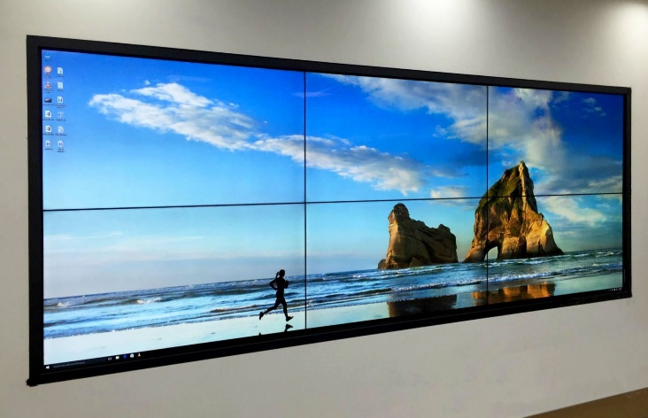

They can write text and graphics anywhere on the screen, and the modifications will remain visible until explicitly overwritten.

This simplicity allows programs to manage the screen contents without worrying about external factors.

However, in Windows, the situation is more complex. Programs can only draw on the client area of their own window, a designated rectangular region within the overall window frame.

This restriction is primarily due to the multitasking nature of Windows, where multiple programs share the screen space.

Additionally, the content of the client area is not guaranteed to persist indefinitely.

**There are several scenarios where the client area may need to be repainted:**

Revealing Previously Hidden Areas: When a hidden portion of the window is brought into view, either by moving the window or uncovering it from behind another window, Windows will send a WM_PAINT message to the window procedure. This message signals the need to redraw the exposed area.

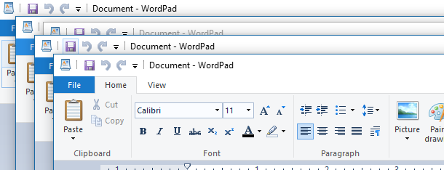

Window Resizing: If the user resizes the window, and the window class style has the CS_HREDRAW and CW_VREDRAW bits set, Windows will again send a WM_PAINT message. This ensures that the client area adapts to the new window size.

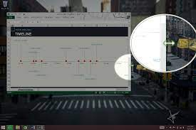

Scrolling: When a program uses the ScrollWindow or ScrollDC functions to scroll part of the client area, Windows will generate a WM_PAINT message to update the visible portion of the client area.

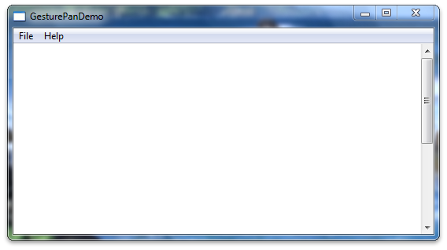

Explicit Invalidation: Programs can explicitly request a repaint of specific areas of the client area using the InvalidateRect or InvalidateRgn functions. This is useful when the program makes changes to its internal data that affect the displayed content.

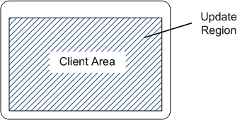

Temporary Overwriting: In some cases, Windows may attempt to save and restore an area of the display when it is temporarily overwritten, such as when a dialog box or menu is displayed over the client area. However, this process is not always reliable, and Windows may sometimes send a WM_PAINT message even when the client area was not actually altered.

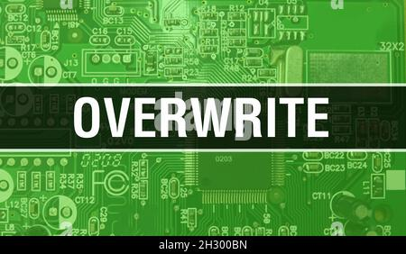

Mouse Cursor and Icon Dragging: In a few specific situations, Windows always saves and restores the overwritten area, triggering a WM_PAINT message only when necessary. These cases include moving the mouse cursor across the client area or dragging an icon within the client area.

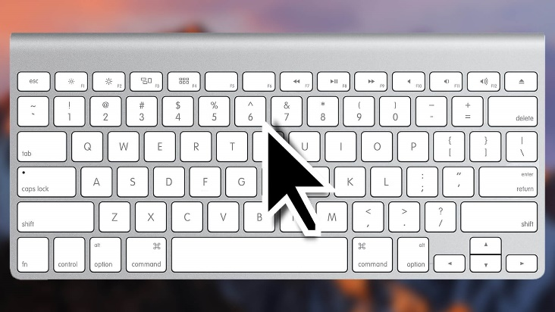

**Dealing with WM_PAINT Messages**

Handling WM_PAINT messages requires a shift in how you perceive drawing on the screen. Instead of directly updating the display whenever your program needs to, you should structure your program to accumulate all the necessary drawing information and only perform the actual rendering when Windows sends a WM_PAINT message. This may seem like an indirect approach, but it promotes a more structured and manageable programming style.

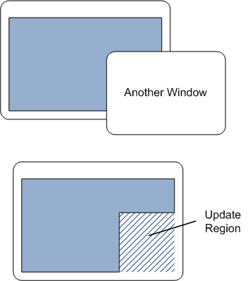

**On-demand Painting**

The WM_PAINT message acts as a trigger, informing your program that the client area needs to be updated. By deferring the actual painting until this message is received, you maintain a clear separation between the data model and the visual representation, making your program more organized and easier to maintain.



**Forcing Repaints**

In situations where your program needs to update the client area outside of a WM_PAINT message, you can explicitly force Windows to generate this message by calling the InvalidateRect function. This will invalidate the specified rectangular region, prompting Windows to add a WM_PAINT message to the message queue.



**Valid and Invalid Rectangles**

While a window procedure should be prepared to repaint the entire client area in response to a WM_PAINT message, it's often more efficient to update only a smaller portion, typically a rectangular region within the client area. This is particularly relevant when a dialog box or other element temporarily overlaps the client area.

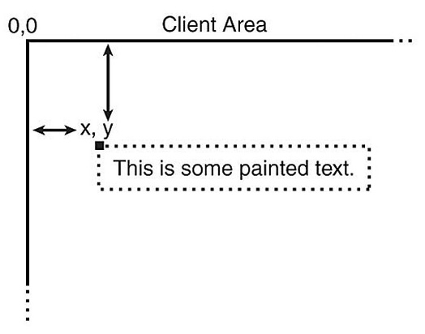

**Invalid Region**

The area of the client area that needs to be repainted is known as an "invalid region" or "update region." The presence of an invalid region is what triggers Windows to send a WM_PAINT message. Your window procedure will only receive a WM_PAINT message if there's an invalid region in your client area.

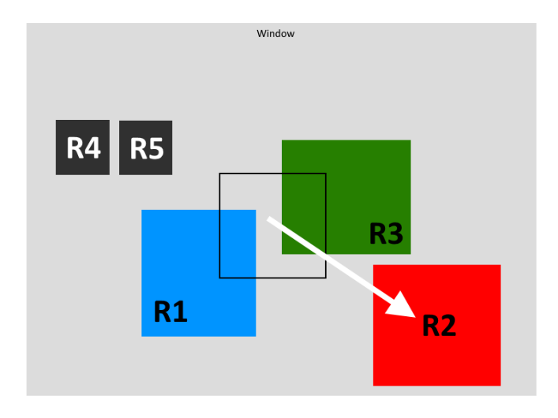

**Paint Information Structure**

Windows maintains an internal "paint information structure" for each window. This structure holds various information, including the coordinates of the smallest rectangle that encompasses the invalid region. This rectangle is called the "invalid rectangle."

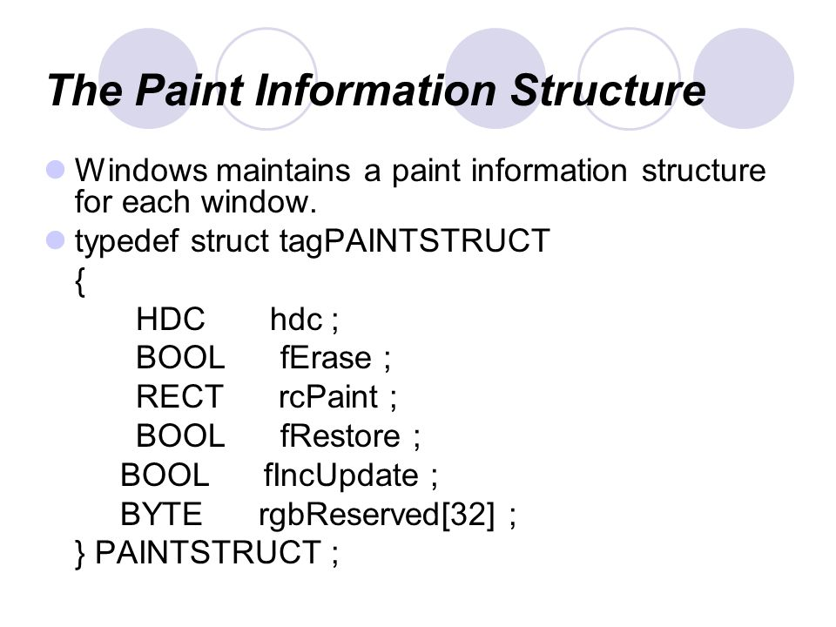

**Invalid Rectangle Updates**

If another part of the client area becomes invalid before the window procedure processes the pending WM_PAINT message, Windows will recalculate the invalid region and invalid rectangle to encompass both areas. It will then update the paint information structure with this new information. Windows avoids placing multiple WM_PAINT messages in the queue for the same window.

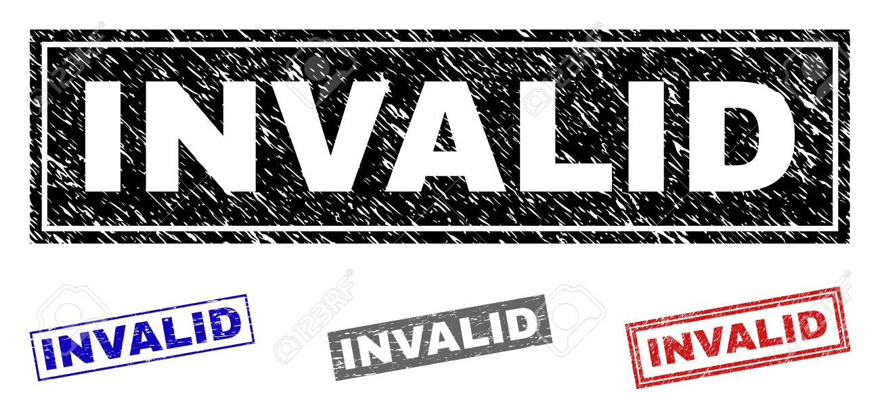

**Invalidating Rectangles**

A window procedure can explicitly invalidate a rectangle in its own client area by calling the InvalidateRect function. If there's already a WM_PAINT message in the message queue, Windows will recalculate the invalid rectangle accordingly. Otherwise, it will add a WM_PAINT message to the queue.

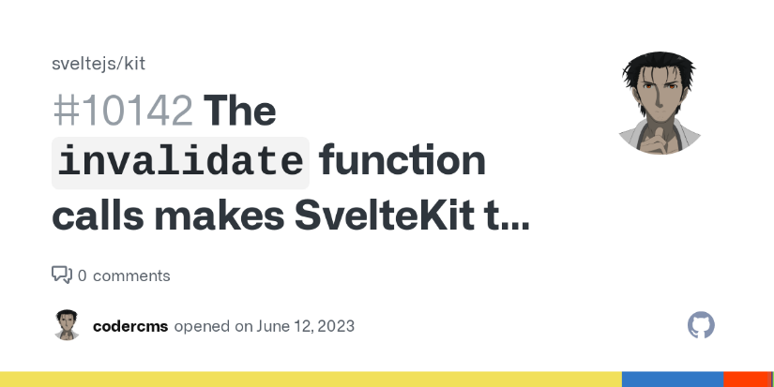

**Retrieving Invalid Rectangle Coordinates**

The window procedure can retrieve the coordinates of the invalid rectangle when it receives a WM_PAINT message. It can also obtain these coordinates at any other time by calling the GetUpdateRect function.

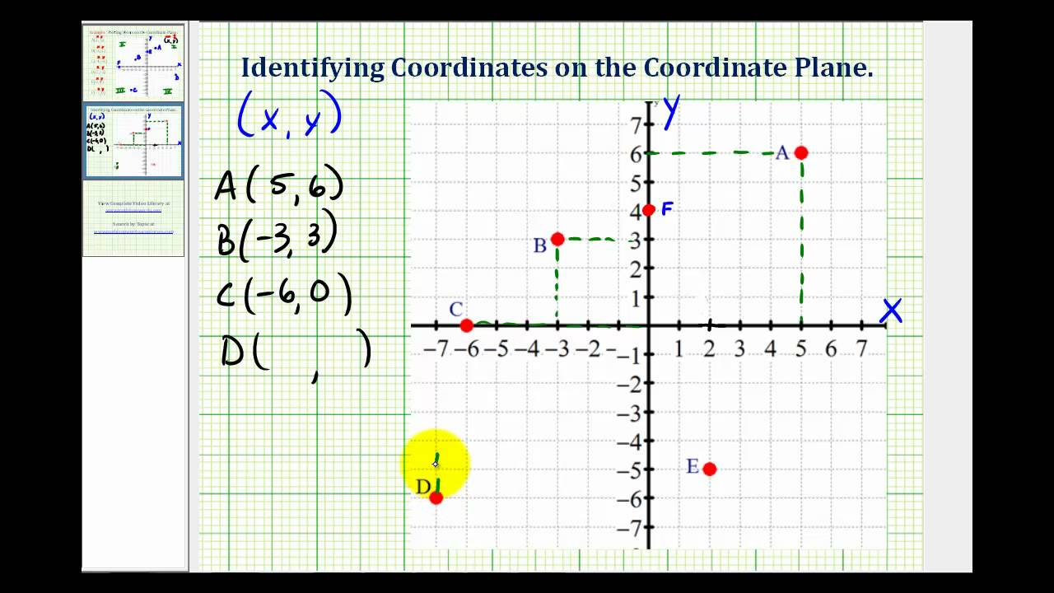

**Validating Rectangles**

Once the window procedure calls BeginPaint during the WM_PAINT message, the entire client area is considered validated. A program can also explicitly validate any rectangular area within the client area by calling the ValidateRect function. If this call effectively validates the entire invalid area, any WM_PAINT message currently in the queue is removed.

In summary, dealing with WM_PAINT messages and understanding the concept of valid and invalid rectangles are essential aspects of Windows programming. By following these guidelines, you can ensure that your program paints the client area efficiently and responsively.

